A Simple Two Terminal Resonance Checker

**Electric Radio March 2012**

By: John F. Hurst , P.E. KU6X

2512 Euclid Crescent East

Upland, CA 91784

ku6x@arrl.net

Last year I was helping my friend Bob Grinder, K7AK (now SK) troubleshoot an SX-28 that was totally dead on two bands. I brought this simple resonant checker (Figure 1) with me. We hooked it up to his scope and RF generator (Figure-4), and within a few minutes we pinpointed the problem to the mixer grid bandswitch. We did this from the top of the chassis (connecting to the tuning capacitor stators) with the power off.

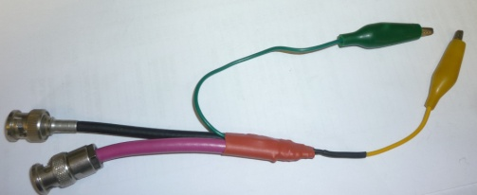

Scope lead Gen lead Gnd Hot

Figure-1: Resonance checker. This version has short coax leads.

I have used this in many other instances where a GDO was useless.

For example I’ve used this (with a scope and generator) to:

* Determine the resonant frequency of shielded tuned circuits
* Perform a cold alignment of receivers and transmitters ( IF, RF and oscillator stages[1]
* Troubleshoot grossly misaligned RF/IF stages on an SX-117 and HT-44. Both were actually inoperative.
* Check crystal parallel, series, overtone and spurious resonances[2]
* Check transducer coils of a mechanical filter
* Check parallel and unwanted series self-resonances of RF chokes.[3]
* Determine the freq and relative Q of IF transformers. I’ve found open and high ESR capacitors[4], and open Litz wire strands (which drastically lowered the Q).
* Determine the taps on (pi net) tank circuits
* Find bad resonant circuit components (shorted turns, wrong cores)
* Determine fr and the L&C values of antenna traps [5]
* check the operation and alignment of a Q-multiplier w/o a receiver
* Check parasitic suppressors for resistor value changes.[6]

This checker uses the textbook method of measuring parallel resonant circuits by feeding a current source (high Z in series with a generator) into the circuit and measuring the voltage across it.

Figure -2 is an LT Spice schematic[7]. The idea here is that modern scopes have a low capacitance input and have a typical sensitivity of 2 to 5 mV/div. An RF generator with an output of 1 Volt or so allows a low value for C1 to minimize the capacitance loading on the LC under test (LC-UT). At frequencies somewhat below the ½ λ resonance of coax line 2 the open circuit scope signal is about equal to C1/(Coax + scope capacitance).[8]

**1meg**

**Cscope**

**13p**

**Td=50n Z0=50**

**T1**

**Td=4.5n Z0=50**

**T2**

**AC 1V**

**Vgen**

**R 1**

**10k**

**R1 Shunt**

**1p**

**C1**

**2p**

**R1 unk**

**C1unk**

**30p**

**L1unk**

**20µ**

**Rgen**

**50**

**LCUT**

**Scope**

**Generator**

**Scope cable Generator cable** **Test Leads Circuit to Check**

**Figure-2: LT Spice Schematic (**including scope and generator equivalent circuits)

I’ve made several versions of this circuit.

The “quick and dirty”(QD) version can be made in a few minutes with:

* Two pieces of coax and connectors, 75 Ω is preferred for the scope lead. I cut an RG-59 video jumper in half.
* A 10K ½ resistor (see text about this)
* Two alligator clip leads (cut in half)
* Short piece of #26 to #30 magnet wire.
* Shrink sleeving

The construction details of the QD version are shown in Figures 3a- 3j.

Shielding between the generator and scope is very important to get a good minimum response with the test leads shorted. Also, the high Z side of the scope coax must be well shielded to minimize AC hum pickup. The method of using a gimmick capacitor for C1 provides shielding for the scope lead.

The circuit loading capacitance across the test leads should be as small as possible to minimize detuning. This capacitance is about 5 pF with this configuration. The upper usable frequency is largely determined by the ½ ** ** resonance of the coax. The upper limit is about 85 MHz with 2.5 feet of RG-59 (75Ω) and about 2 feet with RG-58. Shorter lengths will raise this useful limit. [9]

The generator cable (RG-58) can usually be of any length.[10]

The resistance of R1 is somewhat arbitrary. I’ve found that 10K works well for the majority of H.F. measurement including measuring series resonances. It’s useful to increase R1 to 100 K+ for high impedance parallel circuit measurements such as for testing I.F. transformers. If you wish to make accurate Q measurements using the -3 db delta frequency method,[11] you can substitute a small capacitor (e.g. 2.2 pF) for R1.

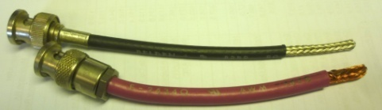

Figure 3a: Stripped coax leads. These short leads can be used with extensions or longer leads can be used. Lower coax is 75Ω

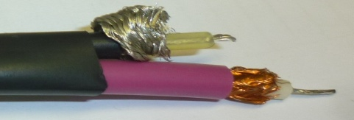

Figure 3b: lead preparation

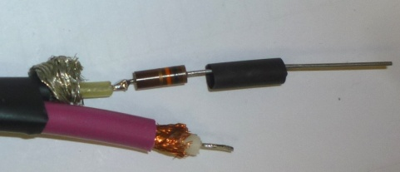

Figure 3c: lap solder R1

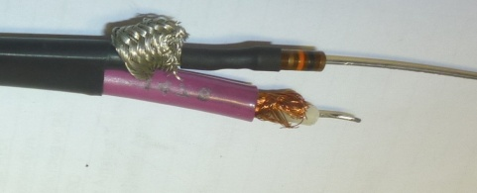

Figure 3d: Shrink over R1

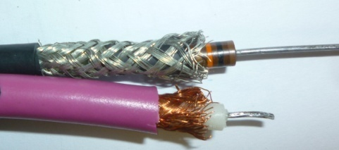

Figure 3e: Shield pulled over R1

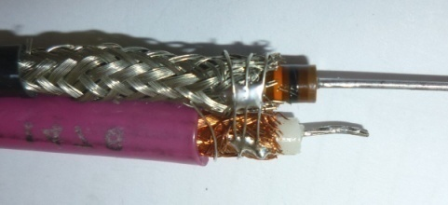

Figure 3f: Shields soldered together

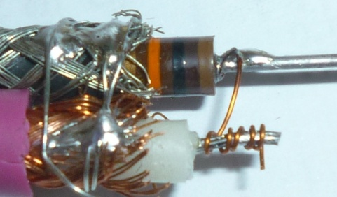

Figure 3g: Gimmick capacitor, C1. About 5 turns of (insulated) #30 magnet wire

Note stranded coax lead is tinned.

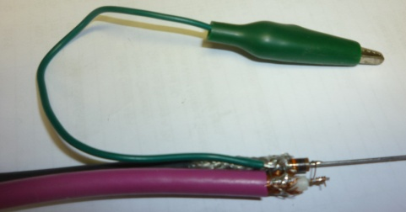

Figure 3h: Ground lead tack soldered to shields

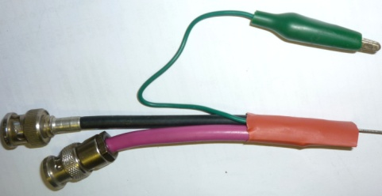

Figure 3i Large shrink sleeving

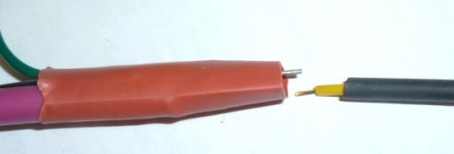

Figure 3j: attach “hot’ lead to R1 and then slide small shrink over joint.

**To test this:**

* Set the scope to its most sensitive range. With the generator OFF the hum level should be very low (< 0.1 mV.)
* With the generator ON (5 MHz) the displayed signal will typically be 5 to 20 mv. Short the two clips together. The signal should drop to less than 0.2 mv.
* Sweep the frequency with the clips open to check the response. It should be reasonably flat up to 80 MHz with a 2.5 foot RG-59 scope cable. The open circuit response will also rise at low frequencies.

The checker is now ready to use. Here’s a typical setup with an HP 8601A generator.

The generator is in the Sweep mode:

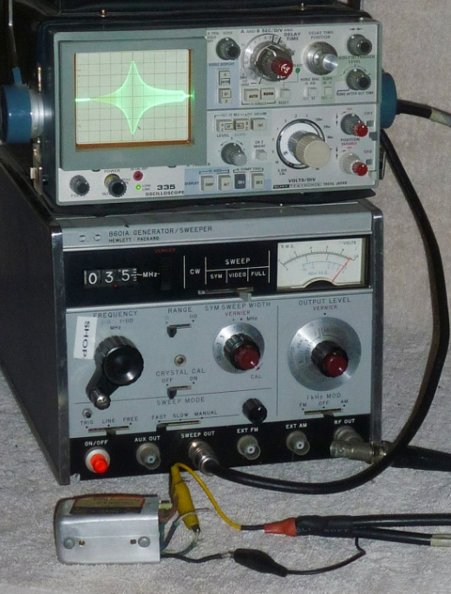

Figure 4: typical setup

The following figures show some typical applications (sweep mode)

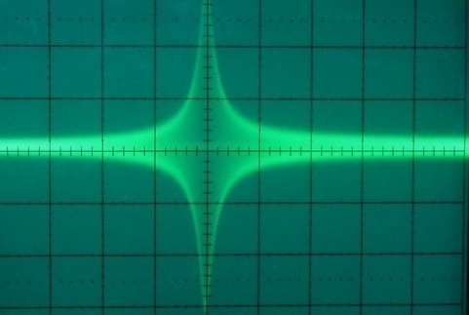

Figure 5: Parallel LC (4.8 uH, 62pf) 16 MHz sweep

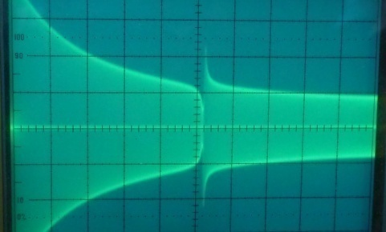

Figure 6: as above but with 2.7 pF in series

Note dip at fr similar to a GDO’s response[12]

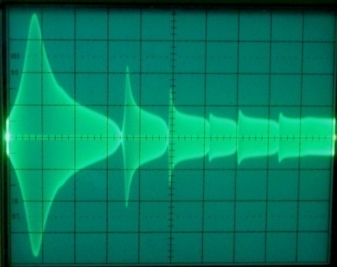

Figure 7: response of a National R175 plate choke. 50 MHz span. Note the numerous series resonances at 17, 24 etc. MHz. The series resonant frequencies are extremely sensitive to any conductor near the *middle* of the choke.

The following figures show the effect of R1 on the Q measurement of an IF transformer:

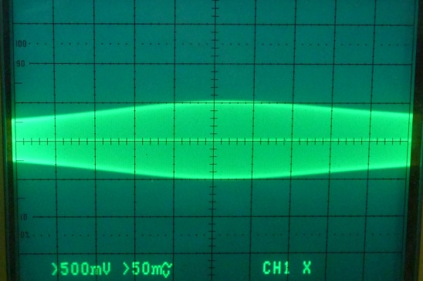

Figure 8a: response of 455 KHz I.F.T with R1=10K, 300 KHz sweep

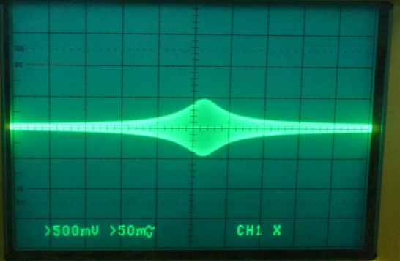

Figure 8b: As above but with R1=100K

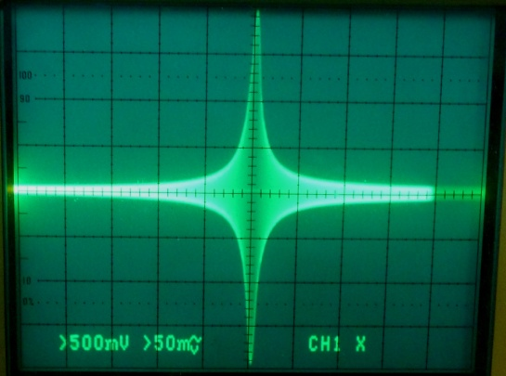

Figure 8b: As above but with R1 changed to a 2.2 pF capacitor

**About RF generators**

My preferred RF generator is an HP 8601A generator, shown in fig 4. This covers 100 KHz to 11Mhz and 1 to 110 MHz in two ranges. This makes it very useful for scanning for unknown resonances. Its maximum output is about 2 volts RMS before harmonic distortion becomes too high Also, since this is a sweeper, it can be use for swept measurements although this isn’t really necessary for the majority of applications,

A conventional RF signal generator works fine. I’ve used my HP 8640B, a Tek 191, a cheap B&K signal generator as well as an MFJ 269B, and 207 antenna analyzers. For IF range measurements you can use an audio oscillator or function generator. Some function generators can sweep.

**The Type 2 version**

If you want to spend a bit more time you can build this checker into a small box. The downside to this configuration is that it has more loading capacitance 8+ pF vs. about 5 pF. It’s also a bit bulkier than the QD version.

I used double sided PCB material to fabricate my box. It took me about 2 hrs to build this version. Most of the construction details are pretty evident from the pictures.

I used a small switch to select 2.2K, 10K, 100K or 2.2 pF for “R1”. There is a bit of capacitance leakage across the switch contacts but it’s of no concern. Note the shield between the generator and scope sides. This should extend about half-way across C1. Also, if you keep the C1 lead from the scope jack close to the bottom of the box, there won’t be any hum problem even w/o a lid on the box. If you wish you can use gimmick capacitors to replace the 2.2 pf units I used. Note that I added a 100K resistor across the scope connector to reduce the LF (hum) response. This helps on the R1=100K and 2.2 pf switch positions with open leads or if you’re measuring circuits with a small series capacitance.

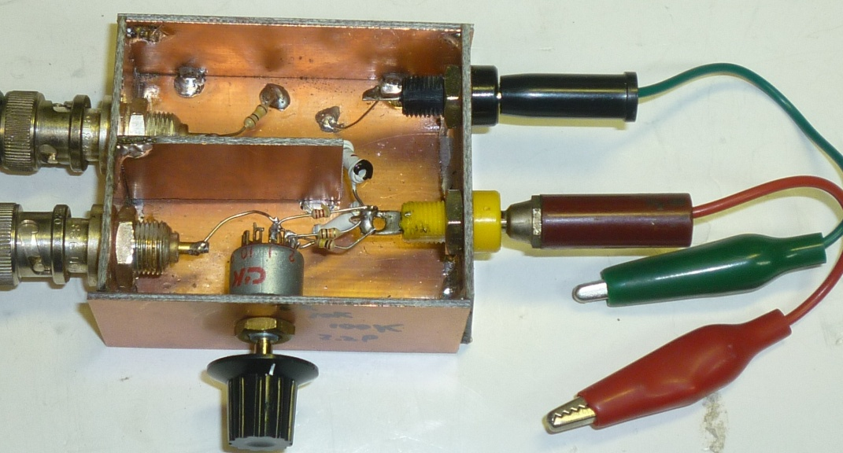

Figure 9a: Resonance checker in a box.

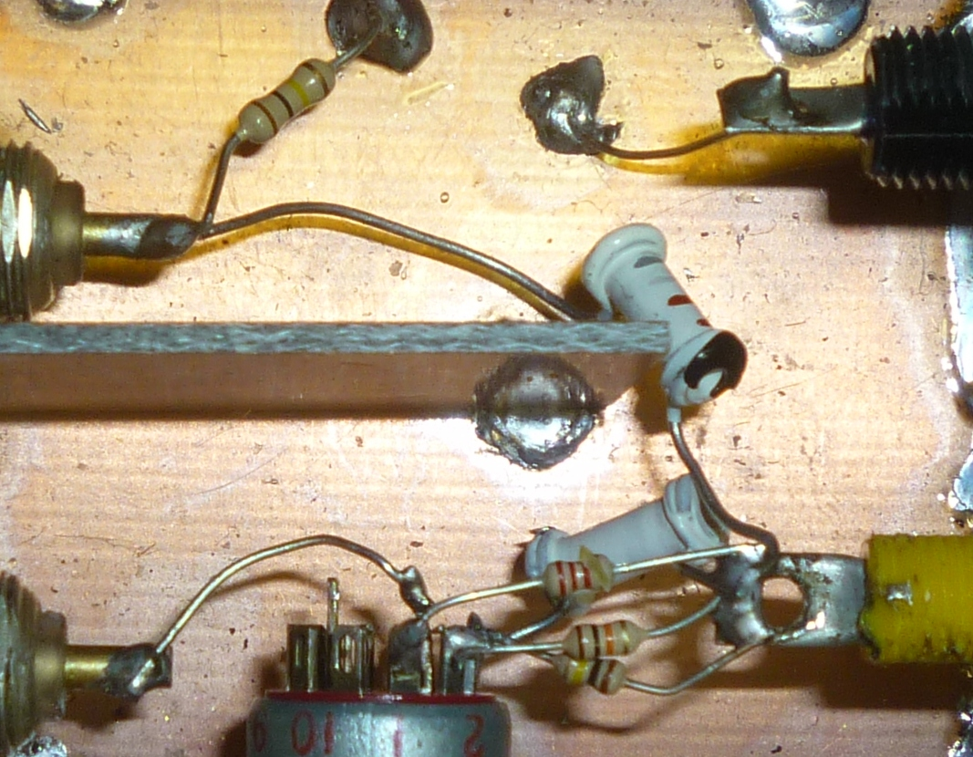

Figure 9b: Close up view

Measuring a National R175 choke’s resonances:

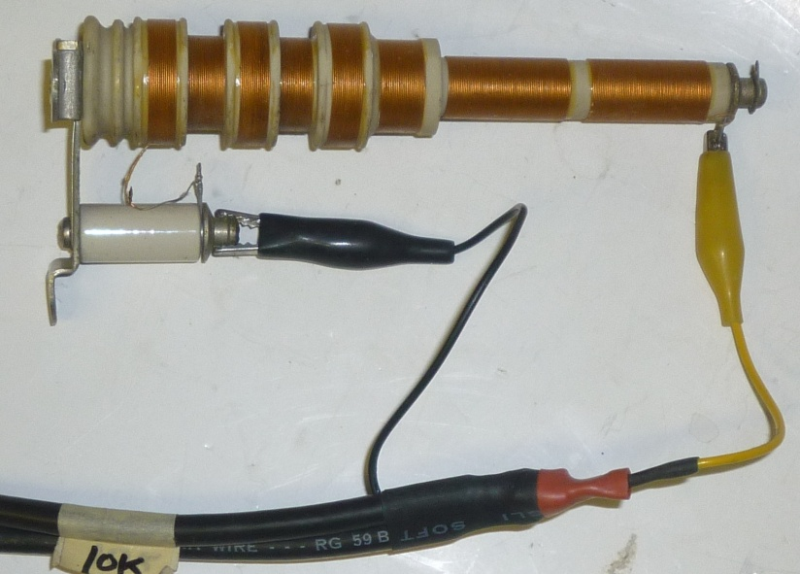

Checking the series resonances of the Plate choke in my Heathkit SB1000 amplifier:

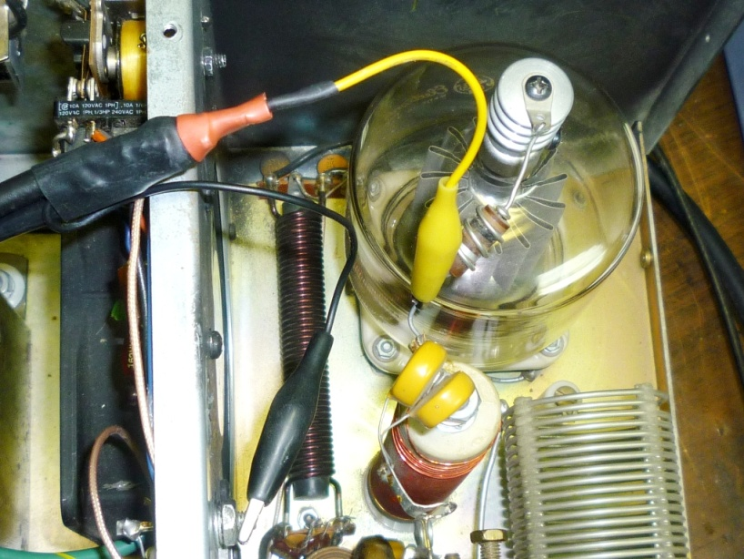

If you do any homebrewing, trouble-shooting or alignment of ham gear you’ll find this to be a really handy gadget.

1. After performing a power-off alignment in receiver RF stages a small peaking of the trimmer capacitors (not the coils) may be necessary for best gain or oscillator accuracy.
2. The HP- 8601A generator is excellent for most applications. It does have higher phase noise than other generators and this will limit its use for sweeping high -Q crystal resonances. It works fine for non-swept crystal measurements. I use an external frequency counter with this generator.
3. See W8JI’s web page for more info on RF chokes
4. This seems to be a fairly common problem with later Hammarlund receivers. I was fighting an HQ-100 that had intermittent low gain. I turned the power off and checked each IF coil’s relative Q. I isolated it to one side of the 2nd IF can, the amplitude at resonance (455KHz) would jump as I wiggled the terminal. I ended up disconnecting the cap buried in the plastic with a Dremel tool and used an external 100pf mica.
5. The actual values of L and C in parallel circuits can be found by first measuring its resonant freq (f1). Shunt the parallel LC with a fairly large known capacitance (Ck) and find the new resonance (f2). Use these values in these two equations to find the actual L and C.

   C = Ck / ((f1/f2)^2-1) and of course L= 1/(C * (2π f1)^2)

   Note that C includes the capacitance of the probe, about 5pF.
6. Add a small capacitor (e.g. 30 pF) across the suppressor. This will allow you to see a peak in the response somewhere near 50 MHz. Check the relative Q (peak amplitude) vs. a known good suppressor. A bad suppressor will have a higher Q compared to one with a good shunt resistor.
7. LTspice is free simulation program with easy to use schematic capture. It’s free from Linear Technology, *www.linear.com*
8. For RF frequencies where the cable + scope input capacitive reactance is small relative to the scope’s DC resistance, an attenuator probe can be simplified down to a simple capacitive voltage divider. The attenuation is close to C1 / Ct where Ct = Scope input capacitance + cable capacitance (Cc). The cable length must be fairly short to keep Cc reasonably low and to avoid cable resonance effects.
9. There are several ways to get around the short scope cable limitation. The easiest way is to use the cable from a 1x or 10x scope probe. The capacitance/ft. is roughly half that of regular coax and they’re resistive loaded to nearly eliminate resonance effects. I used the lead from a 6 ft. Tektronix P6105. I unplugged the coax from the 10x probe and connected the end to a BNC connector. The response with this is nearly flat to > 110 MHz. You must use this with the short cable QD or the Type-2 versions

   Another method would be to use an FET probe with a short cable. A third method would be to build a high Z input active-device impedance convertor into the box.
10. Most lab generators have a 50 ohm resistive output Z so there’s no need to terminate the line (and lose 6 db) to avoid resonance effects.
11. Q = fr/(fh-fl) Where fr is the center frequency, fh and fl are the -3db (0.707) upper and lower frequencies .
12. In a high- Q circuit it’s often possible to use lead to lead capacitance coupling to get a resonance indication without actually connecting the hot lead . This will nearly eliminate capacitive loading on the circuit.