Expanded version of the August 2018 QST article on the Solid State ‘TR switch” rev 7-6-18 John Hurst, KU6X
Contents
- General description, How it’s used
- Circuit Design Discussion
- LTspice Model
- Design Trade-offs
- Optional Low-Pass filter/ Impedance matcher
- High Power Operation
- Construction notes
- PCB notes
- Tuned Magnetic Loop
- Mobile / remote operation with Power Tee
- Use for Classroom Demonstrations
- Additional notes
- Additional File Links
General description
As noted in the QST article my main use for this, was to allow my SDR (software-defined receiver) to use the same antenna(s) as the main HF station. The TRS is a broadband device you can use your SDR to monitor other HF bands using the main antenna. The TRS has a net positive gain so it can drive a splitter for multiple receivers. The normal use in an HF station is shown below:

Here’s a more advanced application:

As mentioned in the QST article a TRS can be used as an active antenna. You can simply insert a short whip (1 to 5 feet) antenna for use as an E-field antenna. If you want to operated the TRS remotely you can use a “power Tee” to feed 12 volts through the output coax as discussed below.
Because the topology of the circuit is optimized for a high Z source it won’t well with a low Z un-tuned (magnetic) loop antenna. It will however, work very well as the amplifier for a tuned magnetic loop antenna. A tuning box is shown below.
Circuit design discussion
For reference here’s the schematic as shown in the QST article:
As described in the article the amplifier uses a combination JFET and a BJT transistor in a cascode configuration. The cascode circuit nearly eliminates the gate-drain miller capacitance effect which reduces the total gate input capacitance. This is important for good sensitivity. The overall voltage gain is about equal to the transconductance (Gm) of Q1 times the load impedance in the collector of Q2. Inductor L2 (47uH) raises the impedance and gain starting at about 3 MHz The gain rolls off the low frequency gain below 160 meters.
For BC Band crystal set antenna application replace L2 with a 1mH inductor and also remove R7. This increases the BC band gain to about 25 db
Q1 is a type J109 JFET operating at a relatively high current (determined by its IDss) for both high a Gm and dynamic range. The output of the Q1, Q2 cascode amplifier drives the output emitter follower Q3.
Inductor L1 resonates with the circuit capacitance to increase both the gain and sensitivity on 6 meters by about 12 dB. L1 is on 37-6 powdered iron core for good Q which is important to minimize the noise floor. The -3dB bandwidth of the 6 meter resonance is about 4 MHz. The gain peak is set to about 51 MHz by bunching or spreading the turns on the core of L1. You can use the SDR for adjusting L1 by looking at where the antenna noise peaks. The effect of this is that on 6 meters a greater portion of the signal power is signal is taken from the main receiver (by about 5 db) . My IC-746 Pro has plenty of gain and the TRS doesn’t reduce its sensitivity.
Setting the gain control to less than half way restores the full signal to the radio on 6 meters.
The “gain” control, which is actually a two stage attenuator, uses two PIN diodes D3 and D4. For the first half of the gain reduction D4 reduces the amplifier gain by lowering the impedance at the collector of Q2. This lowers the gain w/o significantly affecting sensitivity. As the “gain” control is further decreased, zener diode D5 conducts and feeds current into D3. This attenuates the input to the amplifier (and detunes the 6 meter resonance) for additional attenuation. The total gain (attenuation) range is about 15 to 25 dB varies with frequency as seen in the freq response graph. The attenuation of the PIN diodes can be increased by decreasing R5 and increasing C4 but this will affect the noise on 40 meters and below. The PIN diode function is determined by their reverse recovery. In this circuit they behave well down to approximately 1.5 MHz. Below this frequency they still work as attenuators but some IMD products can be noticed. When used in a strong BC band environment it’s best to reduce the BC band sensitivity before using the gain control. The gain vs. frequency for three gain control settings are shown below. The low frequency boost option is shown with the dotted line.

.

Diodes D7 and D8 are shown as 1N4148’S. These limit the output to about +5 dBm and they are also robust enough to protect the TRS against inadvertently transmitting through the output lead. An alternative is to use medium current Schottky diodes which will limit the output to about 0dBm. I successfully tried some MBD-301 diodes but these are now available only in an SMT package. If you want to limit the output to less than +5 dBm use an attenuator or a splitter on the output. I haven’t had any problem running w/o these.
LTspice model
I used LT-spice as part of the design process. This was helpful in designing the gain contouring and analyzing the noise performance. LT-spice allows the use of noiseless resistors, determining the noise contribution of circuit components, and most importantly, the ability to refer noise sources to the input by adding a V(inoise) trace shown below, to the noise simulation plot.
The LT-spice Schematic has some additional components to more accurately reflect parasitic components. Several device models (dot directives) are also included on the schematic. Note that the PIN diodes don’t have Spice models so!N4148’s along with series resistors are used for the simulation. The resistor values are chosen to match the BA479G’s on resistance vs. current with 12 volts on the gain pot input.
Design Tradeoff ( “There’s No Free Lunch”)
The major trade off with a coupling capacitor signal-tap design is between sensitivity loss at lower frequencies (due mainly to impedance mismatch at the amplifier input) and the SWR bump at high frequencies. A good compromise value for C1 is 22pF. This will cause an SWR bump on 6 meters of about 1.37 while still giving a low noise floor on the lower bands.
The noise floor at low lower frequencies (below about 10MHz) is adversely affected by the resistive part of the amplifier’s input impedance. R1 and R5 are made as high as possible for this reason. The LTspice noise analysis referenced to input for the included LTspice file is shown below. To get the modeled equivalent noise input of the TRS square receive bandwidth and multiply.
Actual measured 6dB S/S+N was somewhat better than calculated from the noise analysis. With a 2.5 KHz BW I measured about 0.05uV on 6, 0.11uV on 10 rising to 0.14uV on 80 meters.
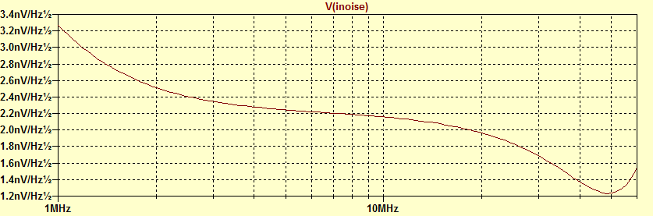
LTspice noise analysis
Harmonic generation notes.
Placing diodes across the antenna will always generate some harmonics. The 2nd harmonic on 6 meters is about -56dB. This is slightly above the FCC spec (-60db) Using an amplifier will reduce this below -60dB. Any 6 meter low pass filter or tuner or resonant antenna well reduce these below -60dB. The harmonics below 30 MHz are well below the -43dB limit.
Optional Low-Pass filter/ Impedance matcher
The SWR that the transmitter sees on 6 meters can be reduced to 1.2 (21dB return loss) by adding a modified low-pass filter at the antenna side of the coax Tee. The filter is designed to have slight inductive reactance by reducing the capacitance facing the TRS by the same value as C1 and the SO239 Tee. Since the return loss of an LPF is very sensitive to the filter parameters it follows that the length of the coax between the TRS and filter is also critical (to an inch or so).: A design for a 5 pole LPF is shown below. This has a 70MHz cut-off frequency and is optimized for a low return loss (>25db) from HF through 6 meters. The TRS input capacitance and connection capacitance is designed into the filter. 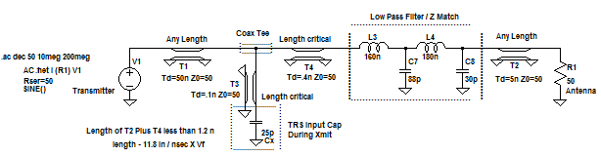r
The easiest way to optimize the filter is to use a return-loss bridge with a spectrum analyzer/tracking generator. You can substitute a 25pF capacitor for the TRS or you can just jumper Diodes D1/2 to simulate transmit operation. You can adjust the turns spacing of LL3 and L4 for the best compromise S11 at 50 and 30 MHz. Here’s a picture of an earlier 7-pole filter using RF surface mount (chip) caps from Mouser.
This filter is good for 100 + Watts.
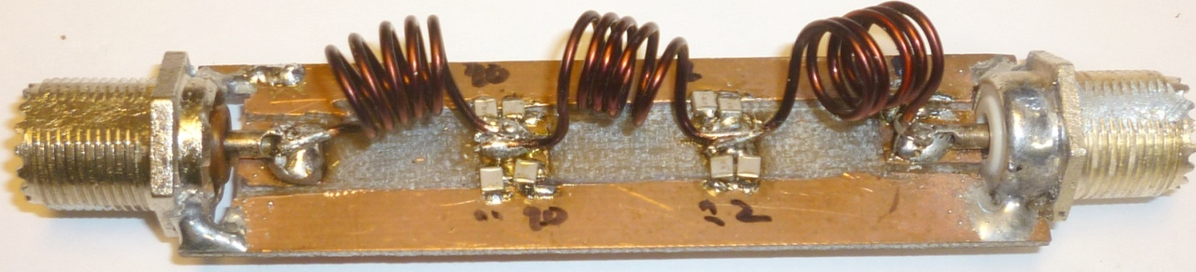
7-Pole Low Pass Filter prototype
One useful tool, resurrected from earlier radio repair days, for aligning a filter is a “magic wand” which consists of a brass rod or tube with a powdered iron or HF ferrite tuning core mounted on the other end. You can insert one or the other end of the “wand” into each coil instead of squeezing or stretching that coil. For larger coils, increase the tubing diameter and use a stack of torroids for the core. Here’s a picture of the magic wand I use:
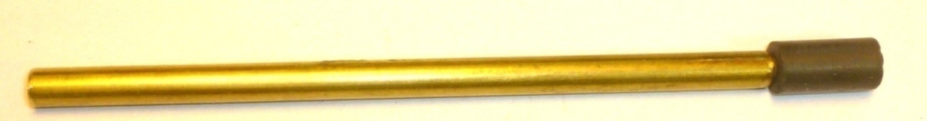
High Power Operation
The “power” PIN diode D1 is fairly expensive ($10) so if you’re not running high power on 6 (<100 W) you can use a conventional clipper circuit by replacing D1 and D2 with 1N4148s.
It’s not obvious by looking at the schematic how the PIN diode behaves. A somewhat simplified explanation is that during transmit, D2 conducts on a portion of the negative half-cycle of the sampled signal. This biases D1 on with a net positive current. D1 now behaves as a low value resistor instead of a diode and it then conducts over most of the full cycle due to its long minority-carrier life-time. This action allows D1, which has a much higher current rating than available signal diodes, to resistively conduct the majority of the current coming through C1.
Construction notes
Here are some pictures that might help when building the TRS Prototype board (note there have been a few minor design changes since this was taken). Top shows islands, Middle parts layout and bottom the finished assembly.

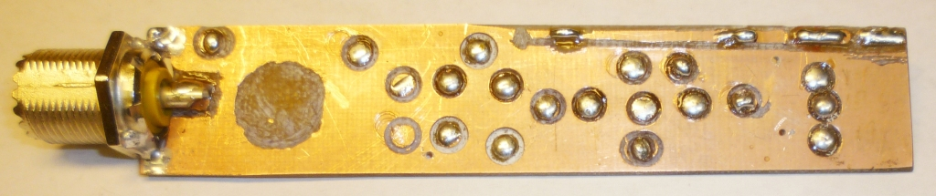
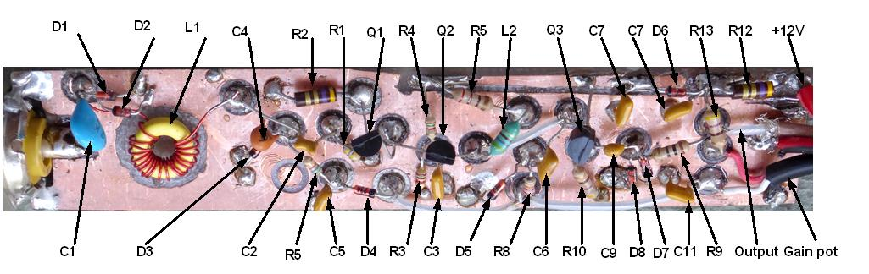
Note: The following components were added after this picture was taken: R6, R7, C10, C12, L3 (LF boost) and L4. The TRS will work w/o these. Several feed- thrus have been be added to connect the top and bottom sides.

Interior view of prototype :
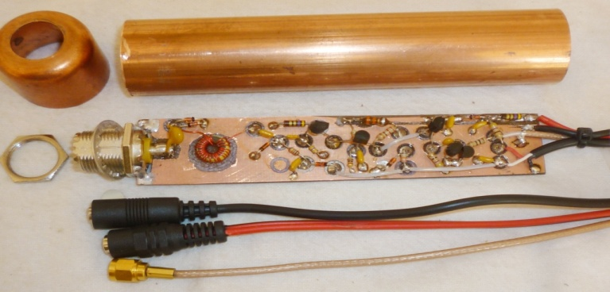

Island cutting in drill Press:
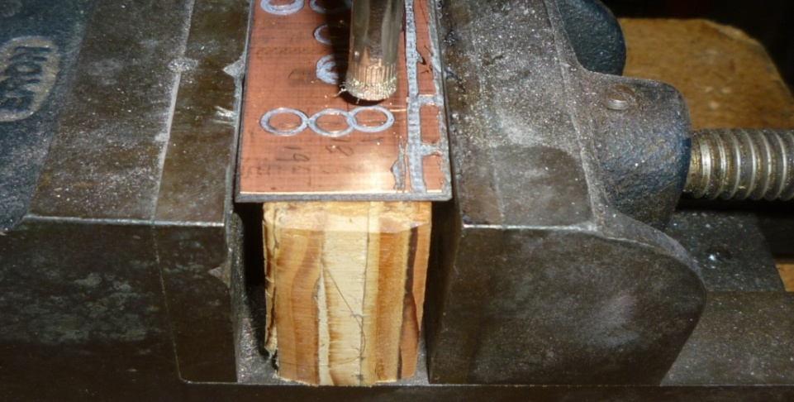
Here’s a simple wooden jig can be used to keep the board square to the connector during soldering. The two holes that hold the connector mount are slotted to set the height of the connector so center pin just touches the board. You can solder both sides of the board to the connector. You will be able to accurately solder the connector to the board with something like this jig. It works for either the “island” board or a printer circuit board.
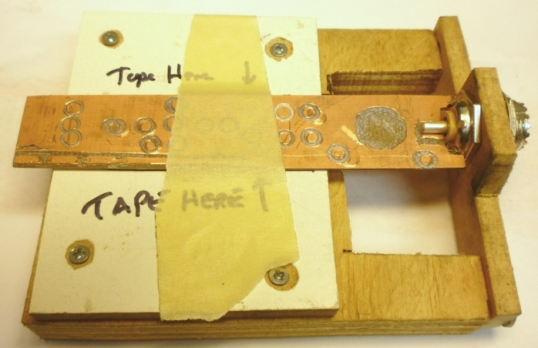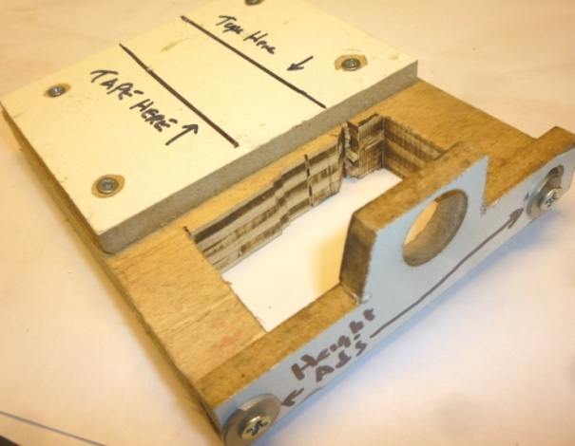
Most SO-239 connectors are now made of cast zinc. It’s much easier to solder to zinc using 63-37 or 60-40 acid core solder. Of course use this only on the connector body and clean up any acid residue with hot water. With acid core solder you can get a nice solder joint.
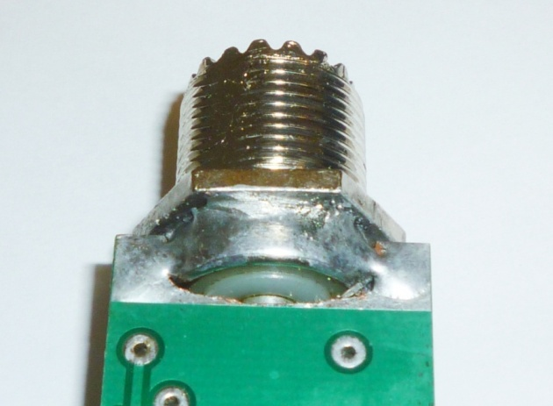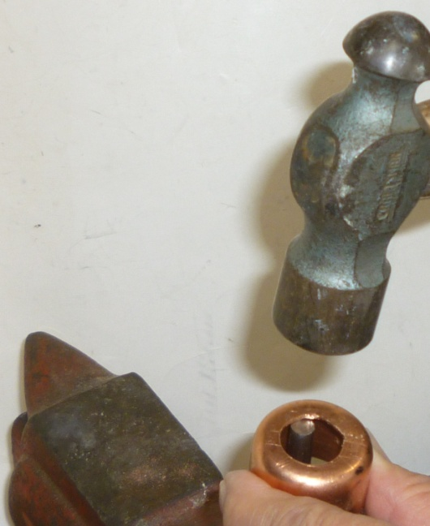
P
Picture of SO-239 soldered to Circuit Board. Peening a flat on the copper end-cap.
Bulkhead single-hole rear-mount SO-239s usually have flats on their threads. The best solution to lock the end cap to the board is to use a 5/8 in. D-hole. D-hole punches are very expensive so another approach is to peen one edge of the hole and file it flat to fit the connector. Use a ¼ inch rod or flat punch held vertically in a vice and use this and a hammer to peen the flat. See the picture above.
A standard square SO-239 can be used if you cut the corners off to fit inside the 1” pipe. A belt sander works well for sanding a flat on the threads.
Printed Circuit Boards
I used Express PCB for the boards. Their special Miniboards are 3.8 in x 2.5 inches from which you can make two boards. The company has a special where you can purchase three miniboards for a low price. You can download their free software to view or modify the layout. The file is TRS-KU6X-Rev B 2-10-17. When you order the boards specify the optional silkscreen and solder masks. When you receive the Miniboard(s) you will need to cut it on the silkscreen marks to get the two 0.9 in. wide boards. You will also have to file the notch for the SO-239 connector. There is some unused PCB so I added two “power Tees” in the otherwise wasted PCB area.
The latest board design includes a switch (pins and shunt) to insert the LF choke (L4). Here’s what you’ll get from Express PCB:
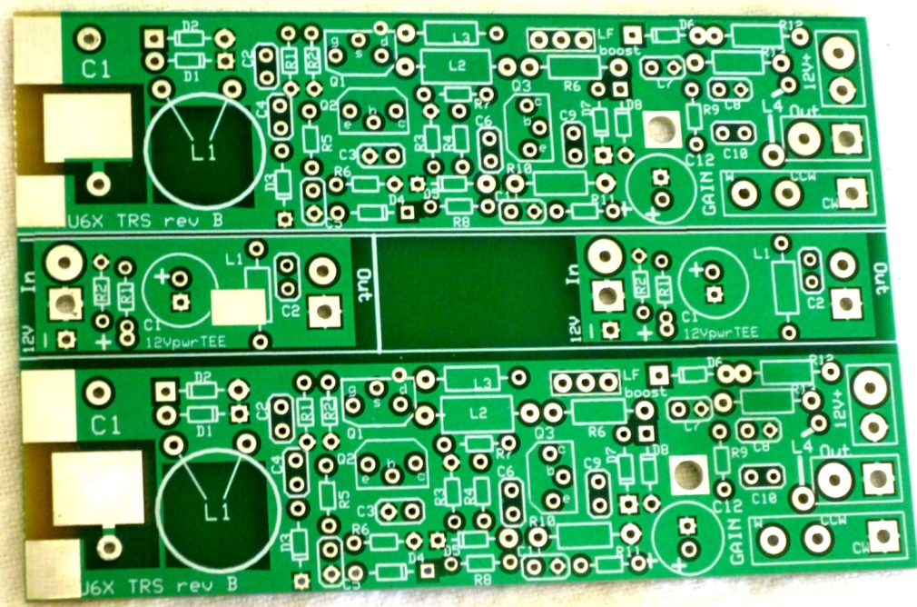
Here’s a picture of the assembled PCB:
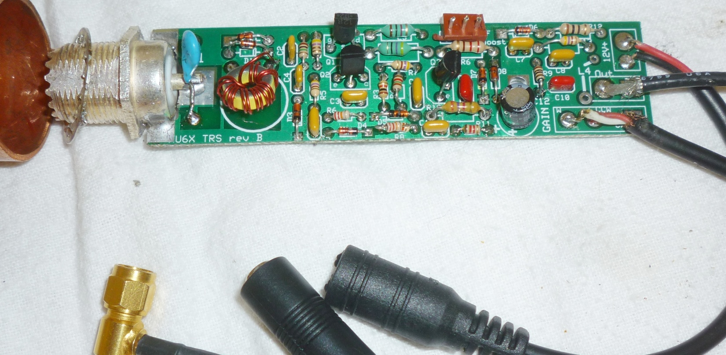
Here’s the silkscreen view: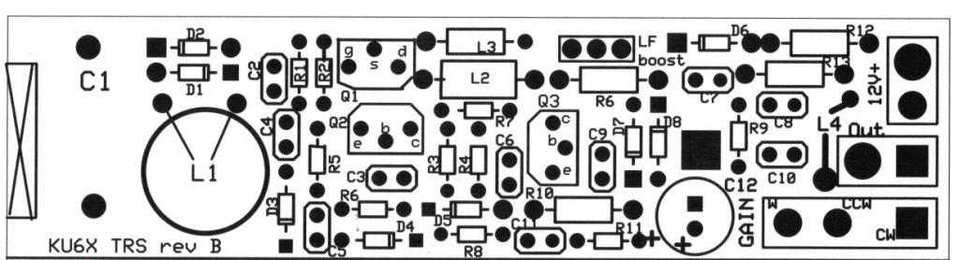

Tuned Magnetic Loop
The TRS design lends itself for use as a tuned magnetic loop. Here’s a schematic of the tuning box that has provisions for adding series and parallel inductors to extend the range of a BC band ferrite rod “loop” antenna.
There is gain loss when extending the tuning range with shunt or series inductance but the TRS has plenty of gain to compensate. My BC band rod has an inductance of 220uH and I use this to tune from below 200 KHz up through 75 meters. You can use a lower inductance loop for use on 80 meters and above. The box is also useful to add front-end selectivity to a whip E-field antenna. This may be useful if there are nearby BCB stations. With all of the inductors switched out the variable cap makes an effective broadband attenuator for the BC band and below. If you wish to experiment with different loops the Excel sheet will be useful for trying different inductance values. It also shows the estimated gain loss when extending the “normal” range of a given loop.
A tuned loop is very useful for nulling out concentrated noise sources. For this to be effective some form of electro-static shielding over the loop and connecting wires. I wound a grounded lead over the loop (not connected at the far end) for the shielding but a solid tube or foil with a longitudinal slit would be better. With some E field sensitivity you might get an asymmetrical polar response (AKA Loop + “sense” antenna).

Front and rear views of prototype magnetic loop + tuning box:

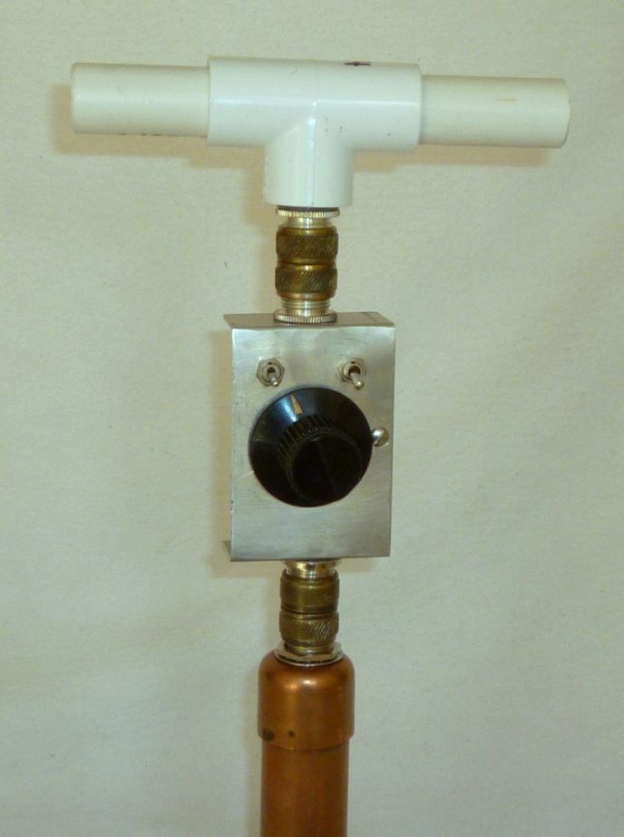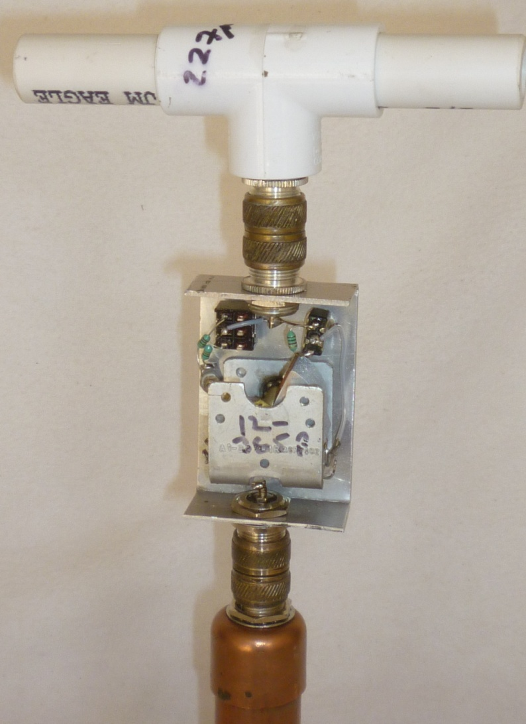

Mobile / remote operation with Power Tee
E-Field Mobile Mount (with 12Volt Power Tee) :
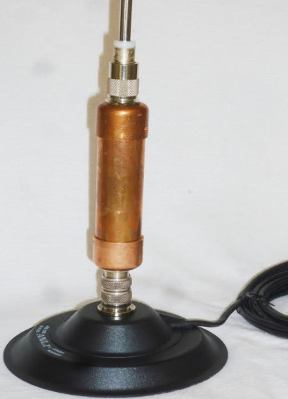

12 Volt Power Tee
Interior view showing output SO-239 connection:
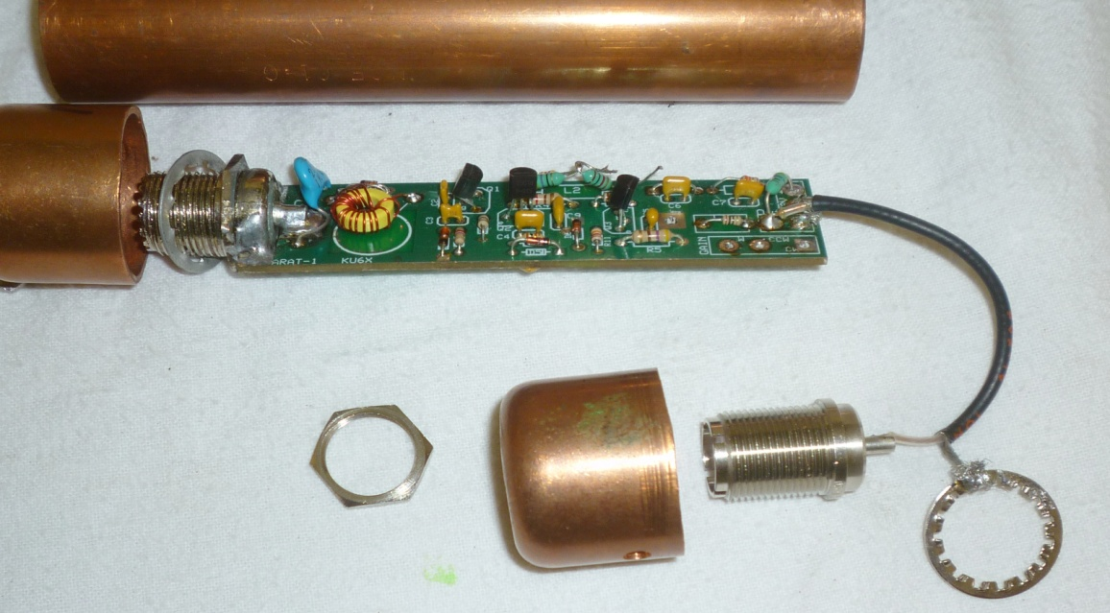

You can feed the 12V DC to the TRS through the output coax by using a “power tee”. In the TRS a choke is added between the output and 12V input as shown on the schematic. This can be from 10uH to 100uH or so. At the receiving end use a series choke a blocking capacitor.
Here’s a schematic for a simple power Tee:
Here is the silkscreen layer for the “Power Tee”
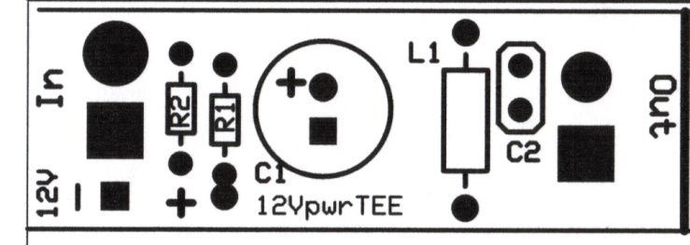

Use for Classroom Demonstrations
To use the TRS in a classroom to drive multiple crystal sets you will probably want to use a 1 mH choke at L2 to increase the BCB gain. This alone will give sufficient output to drive multiple crystal sets with a 5 to 10 foot wire connected to the TRS. The PCB layout has a “shunt” jumper to insert a mH choke. You can increase the gain even more by adding a single RF amplifier stage. As shown below. This amplifier has a flat gain over the BC band of 30+ Db and will drive a large capacitive load so that 10 or more sets can be connected as shown. There is sufficient gain so that a tuned loop in the BC band can be used for applications inside a room. With this amplifier,I noticed that the tuned loop had to be 4 to 5 feet away from my crystal set to avoid magnetically coupled regenerative feed-back (another class room demo?)
Additional Notes
The measured 3rd order intercept, referenced to the input (IIP3) was +12 dBm (on 20 meters). The 1dB compression at maximum gain was -5 dBm (0.15 volts) input and at minimum gain +10 dBm (0.75 volts) input.
I performed some quick tests on the vintage EFJ type 250-39 and B&W 381B tube-type TR switches.
I found that the sensitivity of the new TRS and the EFJ were within a 1dB of each other from 80 through 20 meters. On 160 the TRS was better by about 23 db and on 10 it was better by 6 dB. The EFJ doesn’t pretend to work on 6 meters (it was 45 dB down).
Also note that under some conditions the output of the EFJ can exceed +15 dBm.
The B&W TR-switch suffers from a poor low Z grounded grid front-end design,. It was very noisy on all bands. It does have quite a bit of gain from its switched tuned circuit but the sensitivity was down by 10dB compared to either the TRS or EFJ.
Late mods:
Change R10 from 470 Ohm 1/4 W to 270 ½ W. This improves the 3rd order intercept.
Change L2 to Bournes type 9250A-473-RC This Improves gain
Additional File Links
- Bill of Materials (Excel) with vendor and cost data
- SWR calculations (Excel) shows the effect of the value of C1
- Magnetic Loop Tuner (Excel) shows how to determine Series and Parallel components with associated attenuation
- PCB design file (Express PCB file)
- TRS Simulation (LTspice schematic file) use for AC analysis and Noise analysis. This LT-spice schematic has added components for modeling real components
- Low pass filter simulation (LTspice schematic file) use to determine S11 and S12
- PDF of complete PCB silkscreen layer including power Tee

